Source Control

I used SourceTree which is a tool from the Atlassian suite to manage my version control and project backup. This tool manages the project files which are stored in a GitHub repository.

Below is an image of the commits made to GitHub using SourceTree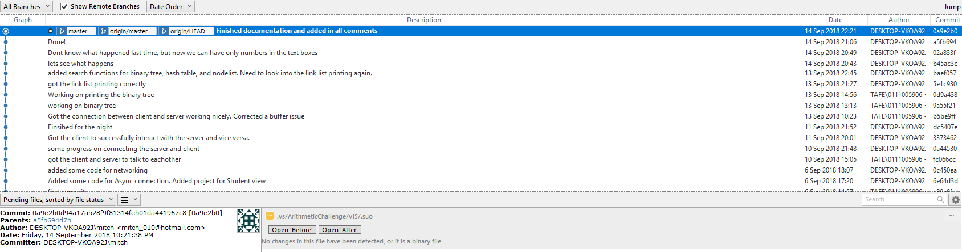

# Manager email

Hello Dave,

To assist us with the manipulation of data to be sent between the applications which will make the entire process easier and faster. We have decided to use a 3rd party library called newtonsoft.json and I deemed it necessary to let you know about this decision.

Please feel free to contact me if you have any further questions.

Thank you for your time.

Regards,

Mitchell Stone

# Client Email

Hello client,

We are looking at implementing a 3rd party library that is associated with a licence agreement and I thought it necessary to let you know about this.

The library used is called newtonsoft.json and there are a few reasons why we would like to implement this;

1. We are using object orientated programming to build this application but due to simplicity, it is easier and faster to send a string across the network.
2. This library is very efficient at converting an object to a string and then back into an object. This is helpful as we are sending strings across the network.

Thank you for your time and if you have any questions about this, please don’t hesitate to contact me.

Regards,

Mitchell Stone

# Closing Email – Manager

Hello Dave,

We can confirm that we have successfully deployed the Arithmetic Challenge Game into the production environment and it is ready for use.

The only concern that we have with the use of the application is that it is only capable of connecting a single client to the server. So, if our client would like additional client applications to connect into the server we would need to look at changing this.

We are very happy with the success of this application.

If there is anything you would like to talk to me about, please don’t hesitate to contact me.

Regards,

Mitchell Stone

# Closing Email – Client

Hello Client,

We are pleased to announce that your application was successfully deployed to the production environment.

This means that you are now able to download and install your application. Please follow the steps in the attached help file to assist you with the deployment.

Congratulations!

If you any questions at all, please don’t hesitate to contact me.

Regards,

Mitchell Stone